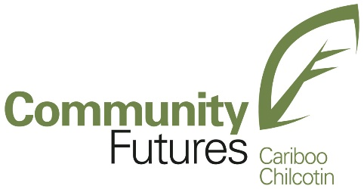

SPONSORSHIP FUND INITIATIVE APPLICATION

Please complete the following application in as much detail as possible, attach additional pages as needed. Be sure to meet/call Community Futures to discuss your project and get feedback for your request as you develop it. (Call Larry Stranberg or Karen Eden @ 250-392-3626) Your request may be evaluated in competition with a number of other applications. To increase your chances of success, be sure to complete all applicable sections and be as clear as possible. Applications are to be received no later than two (2) weeks prior to the regular CFCC Board meeting, (For meeting dates please contact keri-lynn@cfdccariboo.com. 250-392-3626). You may drop off or email your application and any attachments to keri-lynn@cfdccariboo.com.. If applicable, include a copy of your current year’s annual operating budget.

ORGANIZATION OR GROUP

Name of Organization or Group **(Cheque will be payable in this name.)

Mailing Address:
Email:
Phone #:

Legal Structure of Organization or Group (profit / non-profit / local government / first nations / community cooperative / etc.

Mission Statement or Purpose of Organization or Group

Brief History of Organization or Group (Age, Past Projects, Successes or Failures, Who your organization has benefited in recent years.)

Does your organization overlap any other local agencies’ services? If so, please explain.

Is any of the income generated by your organization made payable to or available for the personal benefit of any proprietor, member, volunteer or shareholder of the organization? (Other than paid staff)

ADMINISTRATION

Contact Person

Name:
Mailing Address:
Email:
Phone #:

Are your board members volunteer or paid? Please give details.

Please report the number of volunteers in your organization and number of volunteer hours worked. (not including board members)

Please report the number of paid management & staff members, total hours worked, and total salaries paid on a yearly basis. (not including board members)

- PROJECT

Describe the Project?

What is the length of the Project?

What are the Goals and Objectives of the Project?

Are there any benefits to the local area? If so, what are they?

Will this project create employment in the local area?

How will Community Futures be recognized for its support of the project?

- PROJECT COSTS

What will be the total cost of the project?

How much money are you applying for from Community Futures?

Please list any other partnerships that will be contributing funding (cash or in-kind) to this project.

LIST PARTNERS | IN-KIND | CONTRIBUTIONS
Your Organization |  | $
Community Futures |  | $
Name of other partner |  | $
Name of other partner |  | $
Name of other partner |  | $
TOTAL COST OF PROJECT |  | $
The information included in this application is true and correct to the best of my knowledge.

Authorized Signatory Date

Print Name and Title

